RISC CPU
Design Report

Creation Date：2024.03.01
Version： Final

University of Electronic Science and Technology of China
Chengdu, Sichuan

Document History
Date | Version | Change | Editer
20240304 | beta | Initial One | Li Jincheng
20240312 | gamma | ISA,Architecture and Dataflow | Zhao Ranxun
20240504 | 1.0 | Multi-cycle content added(submodule, tables, structures ) | Li Jincheng
20240612 | final | Complete all the parts | Zhao Ranxun

Abbreviation
Abbreviation | Full Name
IM | Instruction Memory
mux | multiplexer
wb | write back
imm | immediate
rs | source register
rd | destination register
PC | Program Counter
alu | arithmetic logic unit
ROM | Read-Only Memory
RAM | Random Access Memory

Abstract
This design report presents the comprehensive development of a 32-bit RISC CPU based on the RISC-V Instruction Set Architecture (ISA). The CPU is meticulously engineered to execute a diverse set of 31 instructions within a multi-cycle framework, ensuring efficient data processing and state control across various applications. The report delineates the CPU's structural components, including the Instruction Memory (IMEM), Data Memory (DMEM), and the central Controller, which are instrumental in orchestrating the data flow and instruction execution.

The document provides a detailed account of the CPU's operational phases, encompassing Instruction Fetch, Decode, Execution, and Writeback, each meticulously timed to a four-clock cycle process. The data flow for R, S, and B-type instructions is particularly highlighted, illustrating the intricate movement of data through the CPU's subsystems.

Furthermore, the report outlines a systematic approach to verification and testing, utilizing ROM and RAM simulations to validate the CPU's functionality. A series of test cases and their outcomes are presented, demonstrating the CPU's ability to perform complex operations accurately.

The document also ventures into future enhancements, proposing an upgrade to a five-stage pipeline CPU architecture inclusive of a Hazard Detector and Forward Unit. This advancement is set to augment the CPU's throughput, despite a potential slight increase in instruction latency.

The report concludes with the successful implementation of the CPU on an FPGA board, showcasing its practical application in a LEDwater program for industrial control indication. Future work is directed towards optimizing the CPU for higher performance and addressing potential hazards in pipeline execution.

Key Words: RISC-V, ISA, State Machine, Pipeline

Contents
Document History 2
Abbreviation 3
Abstract 4
Figures 7
Tables 8
1 Team information 9
2 Specification 9
2.1 Requirements analysis 9
2.2 Application Scenarios 9
2.3 Overall 10
2.3.1 Function 10
2.3.1.1 Shift Instructions 10
2.3.1.2 Arithmetic Instructions 10
2.3.1.3 Logic 10
2.3.1.4 Compare 10
2.3.1.5 Branch 11
2.3.1.6 Jump & Link 11
2.3.1.7 Load 11
2.3.1.8 Store 11
2.3.2 Input/Output 11
2.3.3 Architecture 12
2.3.4 Dataflow 13
3 Design & Implementation 15
3.1Datapath 15
3.1.1PC submodule 16
3.1.1.1Function 16
3.1.1.2Input/Output 16
3.1.2Regfile submodule 17
3.1.2.1 Function 17
3.1.2.2 Input/Output 17
3.1.2.3 Dataflow 17
3.1.3 Imm-Gen Submodule 18
3.1.3.1 Function 18
3.1.3.2 Input/output 19
3.1.4 Execute submodule 19
3.1.4.1 Function 19
3.1.4.2 Input/output 19
3.1.4.3 Architecture 19
3.1.4.4 Dataflow 20
3.1.5 WB submodule 20
3.1.5.1 Function 20
3.1.5.2 Input/output 20
3.2 Control (State Machine) 20
3.2.1.4 State Diagram 21
3.2.1.5 Signal Assertion 21
3.3 Clock & Reset 23
3.3.1 Clock (clk) 23
3.3.2 Reset (rst) 23
4 Verification & Test 23
4.1 Test Plan & Testbench 23
4.2 Testcase & Result 24
5 Conclusion & Future work 30
5.1 Conclusion 30
5.2 Future work 31
References 34

Figures
Fig 1 Architecture of CPU(including I/O) 12
Fig 2 Architecture of CPU(including Datapah and Control) 12
Fig 3 The Datapath of CPU 13
Fig 4 The data flow of R type instructions in Datapath 14
Fig 5 The data flow of S type instructions in Datapath 14
Fig 6 The data flow of B type instructions in datapath 15
Fig 7 Architecture of Datapath 16
Fig 8 Dataflow of Regfile 17
Fig 9 Architecture of Execute submodule (Comprising 4 modules) 19
Fig 10 Architecture of Control (State Machine) 21
Fig 11 State transition diagram of State Machine 21
Fig 12 Architecture of the CPU 23
Fig 13 The waveform of ALU under different alu_ctrl signal inputs 24
Fig 14 RAM and its values 25
Fig 15 ROM and its Instructions 26
Fig 16 Waveform of simulation results(showing values in registers, PC values and instructions) 28
Fig 17 Waveform of simulation results (showing the store result: ram[5] changes from 6 to 3) 28
Fig 18 Waveform of Instruction3 (showing all related control signals and results) 28
Fig 19 Waveform of Instruction7&8 (showing all related control signals and results) 29
Fig 20 Waveform of Instruction13 (showing all related control signals and results) 29
Fig 21 Implementation of Ledwater 30
Fig 22 Future upgradation of CPU-5 level pipeline with Hazard detector and Forward Unit 31
Fig 23 Pipeline Instruction Example 32
Fig 24 Time/Space Diagram that showcases Hazard Issue 32

Tables
Table 1 Team Information 9
Table 2 Supported ISA format 1 9
Table 3 Shift Instructions 10
Table 4 Arithmetic Instructions 10
Table 5 Logic Instructions 10
Table 6 Compare Instructions 11
Table 7 Branch Instructions 11
Table 8 Jump Instructions 11
Table 9 Load Instructions 11
Table 10 Store Instructions 11
Table 11 Input/Output signals 12
Table 12 I/O of Datapath 16
Table 13 I/O of PC 17
Table 14 I/O of PC 17
Table 15 I/O of Imm-Generator 19
Table 16 I/O of Execute Submodule 19
Table 17 I/O of WB mux 20
Table 18 I/O of Control (State Machine) 21
Table 19 Signal Assertion of Initial State 22
Table 20 Signal Assertion of Fetch State 22
Table 21 Signal Assertion of Decode State 22
Table 22 Signal Assertion of Execute State 22
Table 23 Signal Assertion of WB State 23

Specification

Requirements analysis
The project is aimed at designing a 32bit microprocessor based on Advanced RISC Machine (ARM) architecture with learned knowledge in and out of the course, which is capable of fetching instructions from memory, decoding instructions, executing simple arithmetic and logic operations, transferring data between the processor and memory or I/O, and controlling program flow. 32 general register are given in this CPU.
To avoid complex instruction processing in CISC structure, we referred to RISC-V ISA. Meanwhile, to make control of the datapath, a Moore-type finite state machine is introduced. In all, 31 instructions in 6 types are supported. Based on this, instructions are to be expanded to realize more complicated operations, which contributes to a more complete CPU. The ISA format is as follows.
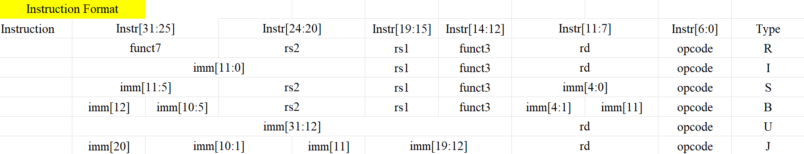

Table 1 Supported ISA format 1

Application Scenarios
The CPU chip has a wide range of application scenarios due to its versatility and efficiency. Firstly, it can be used as an embedded system controller for household appliances such as washing machines, refrigerators, and microwaves, improving energy efficiency through precise control. In IoT devices, the CPU can process data from various sensors, ensuring efficient data collection and real-time processing. It is also crucial in smart home devices, where it can be integrated into smart thermostats, lighting systems, and security systems to enable intelligent automation and remote operation. In industrial automation, the CPU chip can be used for industrial robot controllers, performing simple control tasks to ensure the reliability of operations in assembly lines or manufacturing processes. It can also be used in control devices on production lines, ensuring smooth and efficient management of production processes. For small-scale embedded control devices, the CPU chip can be applied in gaming controllers, providing responsive and precise control inputs to enhance the gaming experience. In conclusion, this CPU is suited for performing data processing and giving state control indication.

Overall

Function

2.3.1.1 Shift Instructions
Shift the value to the right or left and store it in the register.
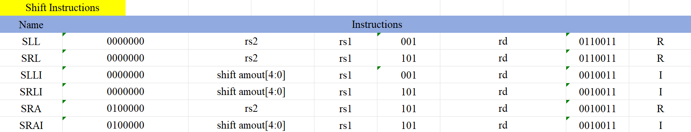
Table 2 Shift Instructions

2.3.1.2 Arithmetic Instructions
Perform basic addition and subtraction operations with pc register and general purpose register.
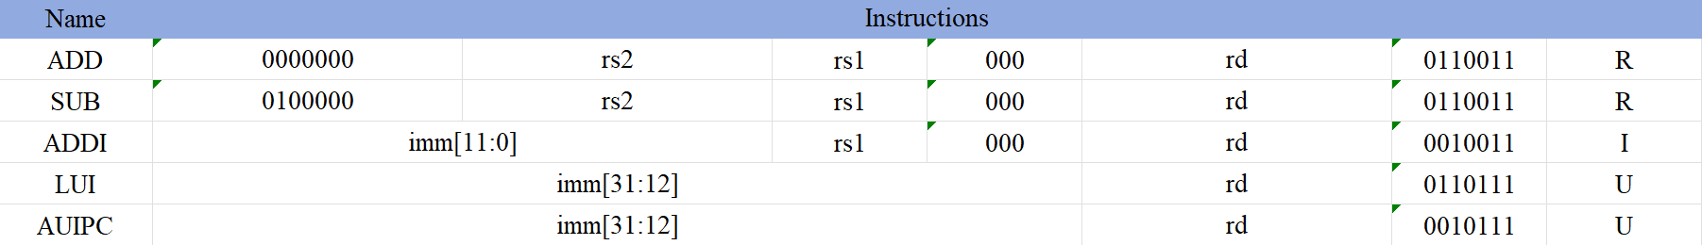
Table 3 Arithmetic Instructions

2.3.1.3 Logic
Perform Boolean logic operation between registers and immediate value.
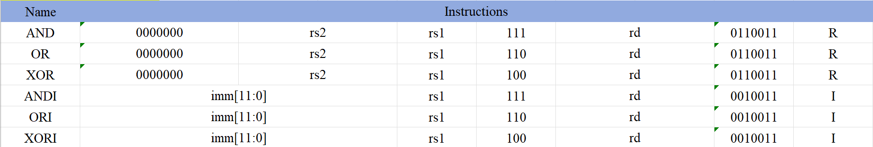
Table 4 Logic Instructions

2.3.1.4 Compare
Compare the different kinds of value in the registers, including immediate, signed integers and unsigned integers.
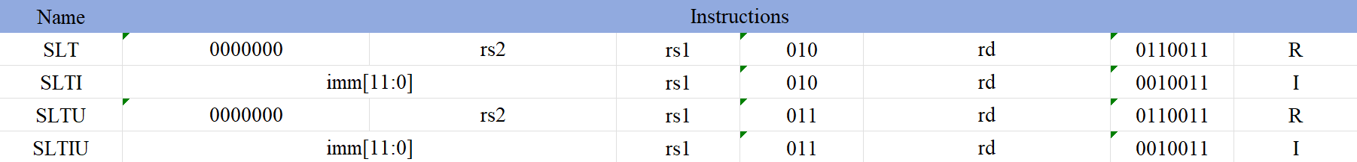
Table 5 Compare Instructions

2.3.1.5 Branch
Compare the values in the registers and jump to the target address once satisfying the condition.
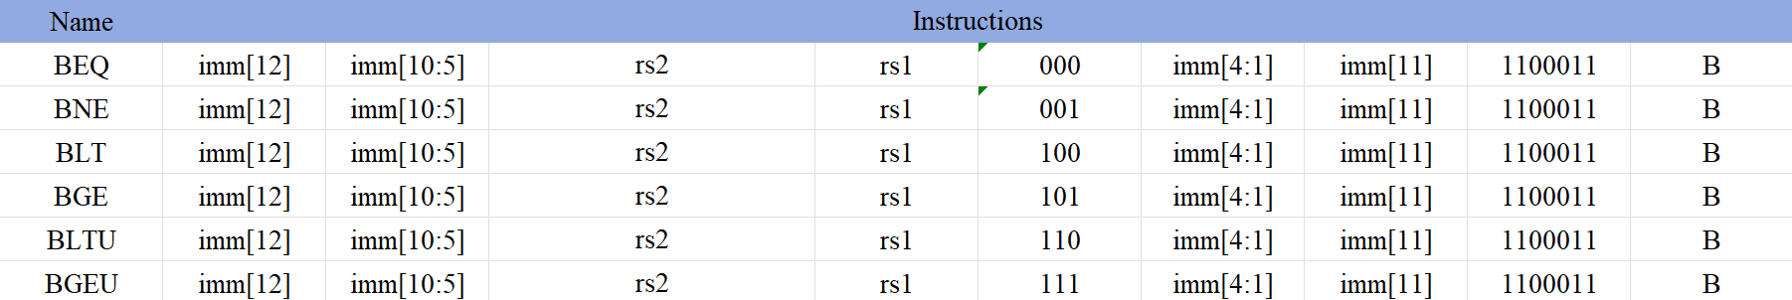
Table 6 Branch Instructions

2.3.1.6 Jump & Link
Jump to the target address and store the return address in the register.
Table 7 Jump Instructions

2.3.1.7 Load
Load the word from the memory to a register.
Table 8 Load Instructions

2.3.1.8 Store
Store the word of register into memory.
Table 9 Store Instructions

Input/Output
The interface of this chip is defined in Error: Reference source not found.
Signal name | I/O | Width (bits) | Fuction Description
clk | Input | 1 | Rising edge Clock signal ,for synchronize
rst | Input | 1 | Reset Signal of CPU
en_in | Input | 1 | Enable ir to write in instruction from memory
Instruction | Input | 32 | Code that determine CPU’s performing function
Data_mem | Input | 32 | Data coming in from memory or
alu_result | Output | 32 | Address for Data Memory
PC | Output | 32 | PC to be sent to Instruction Memroy
Rdata | Output | 32 | Data to be stored in memory
en_fetch | Output | 32 | Enable instruction memory to fetch instruction
en_fetch_data | Output | 32 | Enable data memory to fetch data
en_store_data | Output | 32 | Enable data memory to store data
alu_overflow | Output | 1 | Indication of an overflow
Table 10 Input/Output signals

Architecture
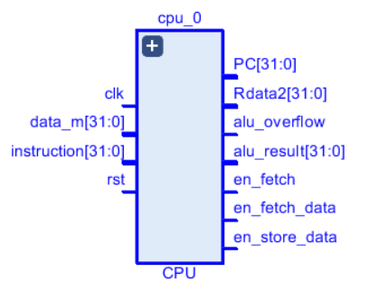
Fig 1 Architecture of CPU(including I/O)

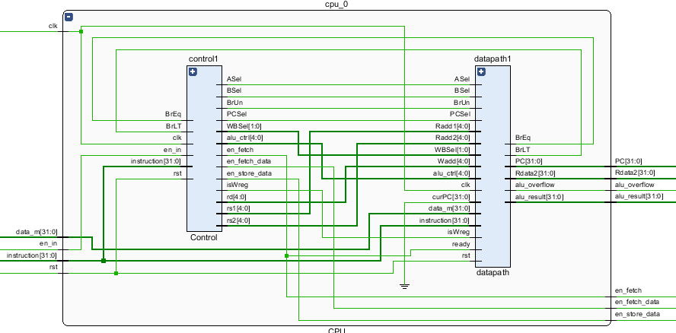
Fig 2 Architecture of CPU(including Datapath and Control)

Dataflow
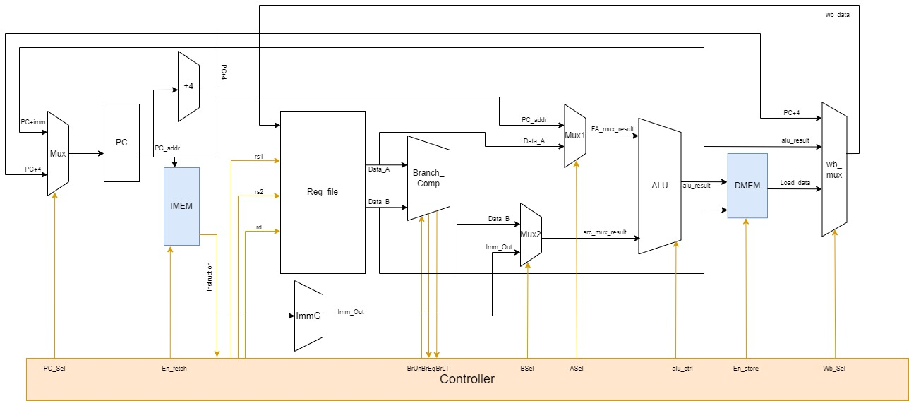
Fig 3 The Datapath of CPU
Our CPU structure is as shown in the above diagram, where IMEM and DMEM (highlighted in blue boxes) are used for data and instruction storage, with IMEM being the instruction memory and DMEM being the data memory. The Controller (highlighted in orange box) is responsible for instruction decoding and the transmission of control signals to the data path. The remaining parts (highlighted in white boxes) constitute the data path. The entire CPU is designed to execute one instruction in four clock cycles, with each cycle executing a module: Instruction Fetch, Instruction Decode, Execution, and Writeback. The Instruction Fetch stage includes write-back selection, instruction address fetching, address incrementing, and instruction retrieval. The sub-modules include PC_Mux, PC, PC_Plus4, and IMEM. The Instruction Decode stage involves instruction decoding, control signal generation, and immediate value processing, with sub-modules such as Reg_file and ImmG. The Execution stage encompasses branch comparison, data selection, and arithmetic operations, with sub-modules like Branch_Comp, Mux1, Mux2, and ALU. Lastly, the Writeback stage involves data loading or storing and write-back selection, with corresponding sub-modules wb_mux and DMEM. Through these four modules, we can implement operations corresponding to 31 instructions.

Now, based on the categorization of six types of instructions, we will briefly introduce the specific data flow of R, S, and B-type instructions in the datapath.
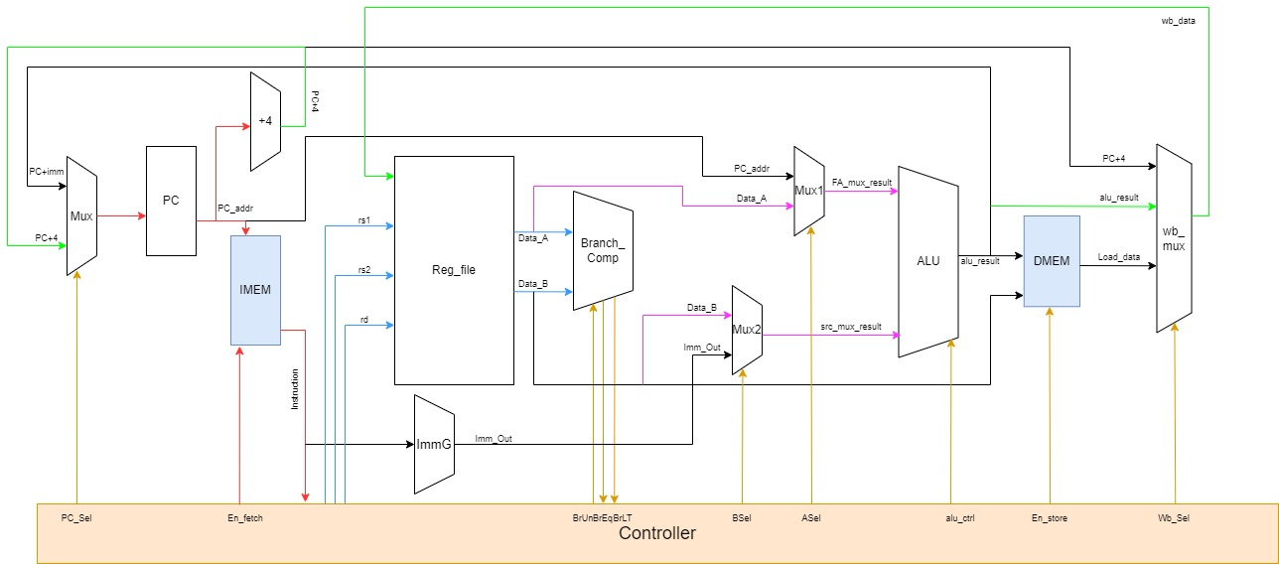
Fig 4 The data flow of R type instructions in Datapath
In the diagram above, we have drawn four different colored lines (including red, blue, purple, and green, excluding brown and black) to represent the data flow in each of the four clock cycles.

In the first clock cycle, the PC is updated through PC_Mux and outputs the address of the current instruction to IMEM, thereby sending the instruction into the Controller for decoding. Meanwhile, PC_Plus4 updates the address and waits for 4 clock cycles before passing it to the Mux. This stage is indicated by the red lines. In the second clock cycle, the Controller completes instruction decoding, transmitting control signals to the datapath. Simultaneously, Reg_file reads Data_A and Data_B based on the incoming rs1 and rs2 addresses. This stage is indicated by the blue lines. During the third clock cycle, based on control signals ASel and BSel, two selectors choose the data just read and pass it to the ALU for computation. This stage is indicated by the purple lines. In the final clock cycle, wb_mux selects alu_result and writes it back to the position of register rd. Simultaneously, PC+4 is fed into PC_Mux for address updating. This stage is indicated by the green lines.

Thus, a complete execution of an R-type instruction is concluded.
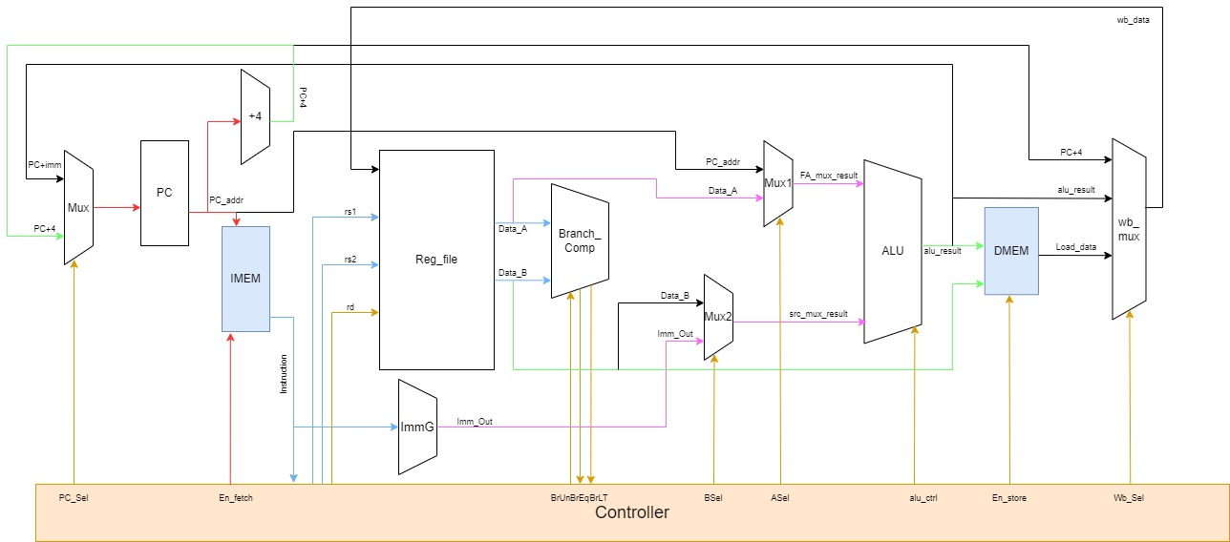
Fig 5 The data flow of S type instructions in Datapath
For S-type instructions, the operation in the first clock cycle is the same as for R-type instructions. In the second clock cycle, the Reg_file only reads the data from rs1 and rs2 and passes it to Branch_Comp, while ImmG generates a complete 32-bit immediate value; this process is indicated by the blue line. In the third clock cycle, the selector chooses Data_A and the immediate value for address calculation. In the final cycle, DMEM receives alu_result and the address provided directly by Reg_file to complete the data storage operation, while PC+4 is updated for address. At this point, a complete execution of an S-type instruction is finished.
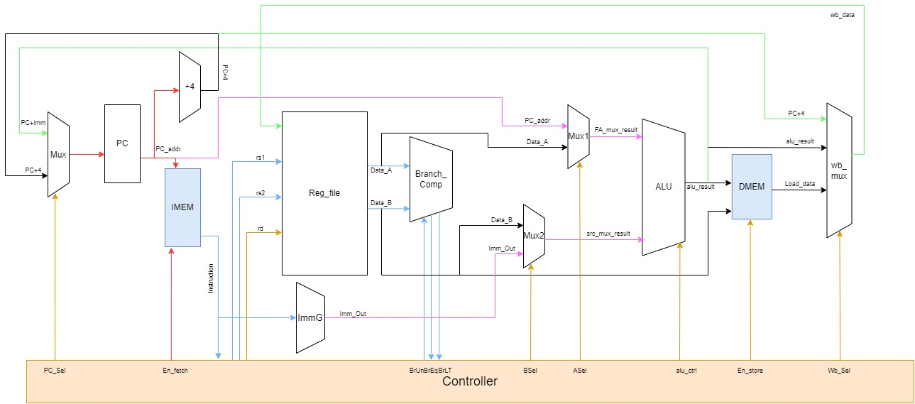
Fig 6 The data flow of B type instructions in datapath
For B-type instructions, the Instruction Fetch and Decode stages are the same as for S-type instructions. In the Execution stage, Branch_Comp makes the appropriate judgment based on whether the Unsigned signal is valid and passes the signal to the Controller. The Controller then decides the selection of the next instruction address: whether it is +4 or +imm. The ALU calculates the value of PC+imm internally. In the final clock cycle, wb_mux selects the PC+4 signal to write back to the register file, then updates the information for the next instruction address. At this point, a complete execution of a B-type instruction is finished.
Based on the above three examples, we can sequentially deduce the data flow of all instructions in the datapath, without further elaboration here.

Design & Implementation

3.1Datapath
3.1.0.1 I/O Table
Signal Name | I/O | Width(bits) | Function Description
ASel | Input | 1 | Address select signal, possibly for ALU operation source A selection
BSel | Input | 1 | Address select signal, possibly for ALU operation source B selection
BrUn | Input | 1 | Unconditional branch signal, controls the program counter update
PCSel | Input | 1 | Program counter select signal, determines the source of PC update
Radd1[4:0] | Input | 5 | Register address select signal 1, selects a register in the register file
Radd2[4:0] | Input | 5 | Register address select signal 2, selects a register in the register file
WBSel | Input | 2 | Write-back select signal, determines which register to write result back to
Wadd | Input | 5 | Write address select signal, determines the address to write back to in the register file
alu_ctrl | Input | 5 | ALU control signals, control the type of operation performed by the ALU
branch | Input | 1 | Branch signal, controls pc change when branch happens
clk | Input | 1 | Clock signal, used to synchronize CPU operations
data_m | Input | 32 | Data memory input, used for reading from or writing to data memory
en_fetch | Input | 1 | pc enable signal for next pc renewing
instruction | Input | 32 | Current instruction input, used for instruction decoding and execution
isWreg | Input | 1 | Write-back register signal, indicates whether to write result back to a register
rst | Input | 1 | Reset signal, used to initialize or reset CPU state
BrEq | Output | 1 | Branch equal signal, controls equal condition branching logic
BrLT | Output | 1 | Branch less than signal, controls less than condition branching logic
PC | Output | 32 | Program counter, stores the address of the current instruction
Rdata2 | Output | 32 | Data read from data memory or the second operand read from the register file
alu_overflow | Output | 1 | ALU overflow signal, indicates arithmetic operation overflow
alu_result | Output | 32 | ALU operation result, output to the register file or used for other operations
Table 11 I/O of Datapath

3.1.0.2 Architecture
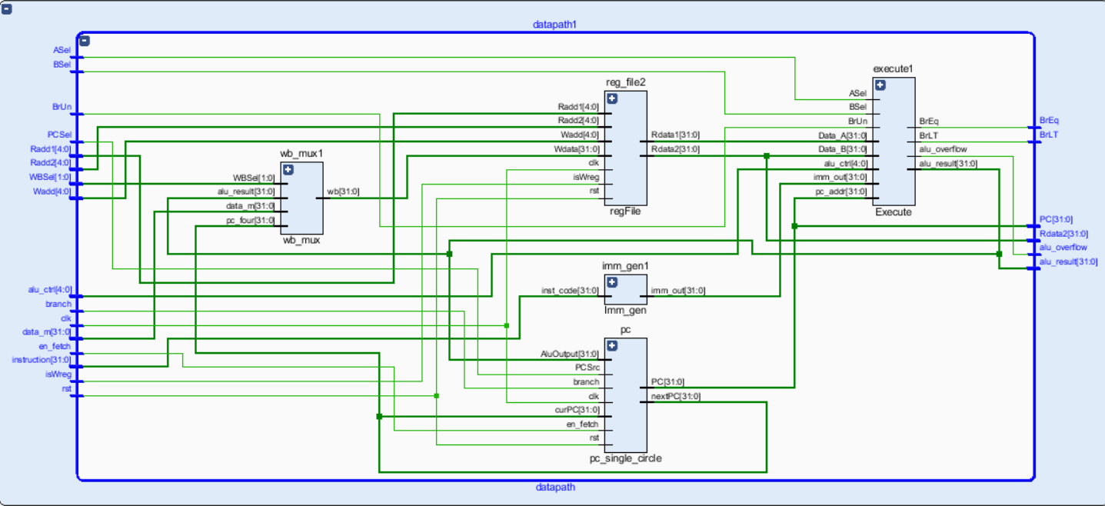
Fig 7 Architecture of Datapath

3.1.1PC submodule

3.1.1.1Function
A group of register where stores the address of instructions to be fetched in Instruction Memory. When receiving an enable signal from state machine, it gives out an address to the memory outside to fetch an instruction for CPU to execute.

3.1.1.2Input/Output

Signal name | I/O | Width (bits) | Fuction Description
clk | Input | 1 | Clock signal ,for synchronize
rst | Input | 1 | Reset Signal
PCSrc | Input | 1 | Decide the which pc to be picked
AluOutPut | Input | 32 | One of PC source, equal to PC+imm
curPC | Input | 32 | One of PC source, equal to PC+4
PC | Output | 32 | Address for Instruction Memory
nextPC | Output | 32 | PC+4, give out to PC_mux and wb_mux
branch | Input | 1 | Branch signal, controls pc change when branch happens
en_fetch | Input | 1 | pc enable signal for next pc renewing
Table 12 I/O of PC

3.1.2Regfile submodule

3.1.2.1 Function
Regfile is the general register where data is stored, or data is read from.

3.1.2.2 Input/Output
Signal name | I/O | Width (bits) | Fuction Description
clk | Input | 1 | Clock signal ,for synchronize
rst | Input | 1 | Reset Signal
Radd1 | Input | 5 | Address for rs1
Radd2 | Input | 5 | Address for rs2
Wadd | Input | 5 | Address for rd
Wdata | Input | 32 | Data written back to register
isWreg | Input | 1 | Enable signal for register to read/store data
Rdata1 | Input | 32 | Data read out from register from rs1
Rdata2 | Input | 32 | Data read out from register from rs2
Table 13 I/O of PC

3.1.2.3 Dataflow
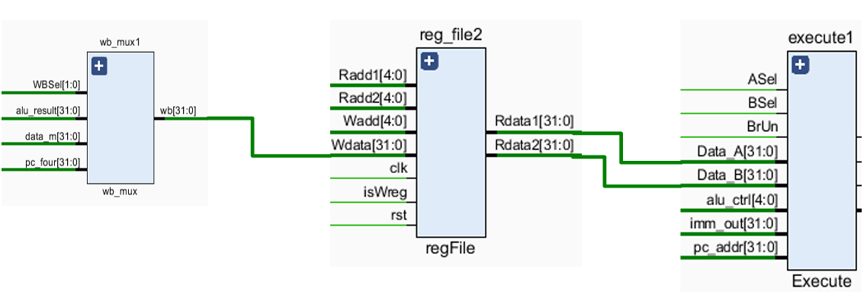
Fig 8 Dataflow of Regfile

Radd is the address for reading data. Wadd is the address for writing data.
Wdata is the data written to rd. isWreg is the enable signal for reading data.
As “isWreg” is asserted and a clock rising edge comes, regfile writes data in from wb_mux
Otherwise, regfile reads data to execute module as clock rising edge arrives.

3.1.3 Imm-Gen Submodule

3.1.3.1 Function
The Imm_gen module extracts and constructs the correct immediate value from the 32-bit instruction code based on different RISC-V instruction types and encoding rules.
(1)R-type instruction: register-to-register operation does not require an immediate operand. Therefore, imm_out is set to all zeros.
(2)I-type instruction: The immediate operand is stored in bits 31:20 of inst_code, and the sign bit (inst_code[31]) is replicated to the upper 20 bits:
Sign extension: Use {{20{inst_code[31]}}} to create a 20-bit field with all bits set to the value of inst_code[31] (i.e., the sign bit).
Concatenation: Concatenate the sign-extended result with inst_code[31:20] to form the final 32-bit immediate operand.
(3)B-type instruction (short branch). The immediate operand is composed of multiple bit fields and requires some bit manipulation.
Sign extension: Use {{(19) {inst_code[31]}}} to create a 19-bit field with all bits set to the value of inst_code[31].
Concatenation: Concatenate the sign-extended result, inst_code [31], inst_code[7], inst_code[30:25], inst_code[11:8], and append a 0 at the end.
(4)U-type instruction the immediate operand is obtained by left-shifting bits 31:12 of inst_code by 12 positions.
Left shift: Left-shift inst_code[31:12] by 12 positions to form a 32-bit immediate opera
(5)J-type instruction. The immediate operand is constructed similarly to a B-type instruction, but with different bit selections and offset calculations.
Sign extension: Use {{10{inst_code[31]}}} to create a 10-bit field with all bits set to the value of inst_code[31].
Concatenation: Concatenate the sign-extended result, inst_code [31], inst_code[19:12], inst_code[20], inst_code[30:21], and append a 0 at the end.
(6)S-type instruction (store instruction). The immediate operand is constructed similarly to an I-type instruction, but with different offset bit selections.
Sign extension: Use {{20{inst_code[31]}}} to create a 20-bit field with all bits set to the value of inst_code[31].
Concatenation: Concatenate the sign-extended result, inst_code[31], inst_code[30:25], inst_code[11:8], inst_code[7], to form the final 32-bit immediate operand.
(7)Default Case
If test does not match any of the above cases, imm_out is set to all zeros. the sign-extended result, inst_code [31], inst_code[30:25], inst_code[11:8], inst_code[7], to form the final 32-bit immediate operand.

3.1.3.2 Input/output
Signal name | I/O | Width (bits) | Fuction Description
inst_code | Input | 32 | Instructions to be decoded to generate imm
imm_ | Input | 32 | Imm generated
Table 14 I/O of Imm-Generator

3.1.4 Execute submodule

3.1.4.1 Function
It includes 2 mux, ALU and branch compare unit. This module performs calculations (logically and arithmetically) in CPU and branch compare.

3.1.4.2 Input/output
Signal name | I/O | Width (bits) | Fuction Description
ASel | Input | 1 | Select rs1 or pc
Bsel | Input | 1 | Select rs2 or imm
BrUn | Input | 1 | Decide whether to perform signed compare or not
Data_A | Input | 32 | Rs1, source for alu
Data_B | Input | 32 | Rs2, source for alu
alu_ctrl | Input | 5 | Opcode that decide operation that alu performs
imm_out | Input | 32 | Imm, source for alu
pc_addr | Input | 32 | Pc, source for alu
Rdata2 | Input | 32 | Data read out from register from rs2
BrLT | Output | 1 | Output of branch compare, a<b
BrEq | Output | 1 | Output of branch compare, a=b
alu_overflow | Output | 1 | Indication of an overflow
alu_result | Output | 32 | Result of calculations in alu
Table 15 I/O of Execute Submodule

3.1.4.3 Architecture

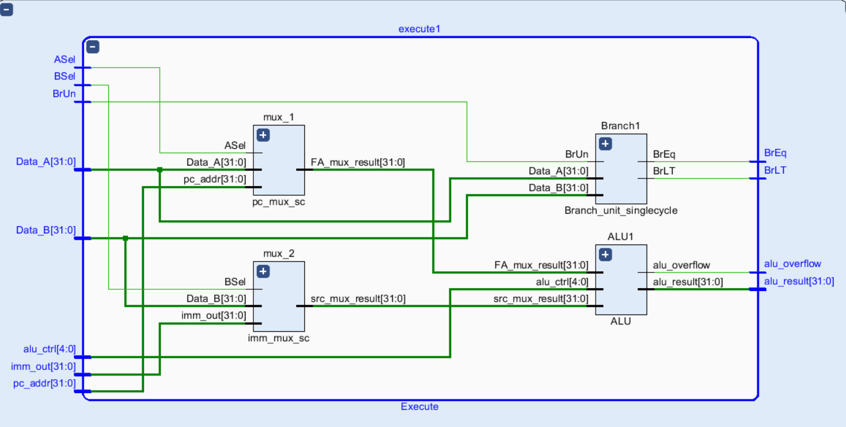
Fig 9 Architecture of Execute submodule (Comprising 4 modules)

3.1.4.4 Dataflow
Mux1 selects value from register or PC address. Mux2 selects value between register and immediate.
ASel is for mux1. BSel is for mux2. They both come from state machine in control.
These two mux results are to be sent to ALU for calculation. alu_ctrl coming from state machine in control is the control signal that decides which operation to be performed. alu_result is sent to wb_mux or sent to Data Memory.
BrUn is from state machine in control and decides whether to perform signed value comparison. The result is BrEq if Data_A equals to Data_B, while BeLT is asserted if Data_A is less than Data_B.

3.1.5 WB submodule

3.1.5.1 Function
This module is the mux that selects the value to be written back in the Regfile register.

3.1.5.2 Input/output
Signal name | I/O | Width (bits) | Fuction Description
WBSel | Input | 2 | Select value to be write back
alu_result | Input | 32 | Result from alu, mux source
data_m | Input | 32 | Data fetched form memory, mux source
pc_four | Input | 32 | PC+4, mux source
Wb | Output | 32 | Value to be written back
Table 16 I/O of WB mux

3.2 Control (State Machine)
3.2.1.1 Function
This control unit uses state machine to control the execution instructions. It includes five steps, initial, fetch, decode, execute and write back. Initial step is to initialize the signals. Fetch step is to fetch the instructions from the PC module. Decode step is to decode the instructions, perform main computations and assert various control signals following different opcodes. Execute step is to continue executing the instructions, avoiding some timing problems (related to reading from/writing to ram). Write back step is to write back certain data to the register.
3.2.1.2 I/O
Signal name | I/O | Width (bits) | Function Description
instruction | Input | 32 | the instruction to be executed
BrEq | Input | 1 | Output of branch compare, a=b
BrLT | Input | 1 | Output of branch compare, a<b
PCSel | Output | 1 | Decide the which pc to be picked
en_fetch | Output | 1 | Decide whether to fetch the instructions and renew pc value
branch | Output | 1 | Branch signal, controls pc change when branch happens
rs1 | Output | 5 | Address of rs1
rs2 | Output | 5 | Address of rs2
rd | Output | 5 | Address of rd
BrUn | Output | 1 | Decide whether to perform signed compare or not
BSel | Output | 1 | Select rs2 or imm
ASel | Output | 1 | Select rs1 or pc
BrEq | Output | 1 | Output of branch compare, a=b
BrLT | Output | 1 | Output of branch compare, a<b
alu_ctrl | Output | 5 | Opcode that decides operation that alu performs
en_store_data | Output | 1 | Enable signal for register to store data
en_fetch_data | Output | 1 | Enable signal for memory to read data
WBSel | Output | 2 | Select value to be write back
Table 17 I/O of Control (State Machine)
3.2.1.3 Architecture
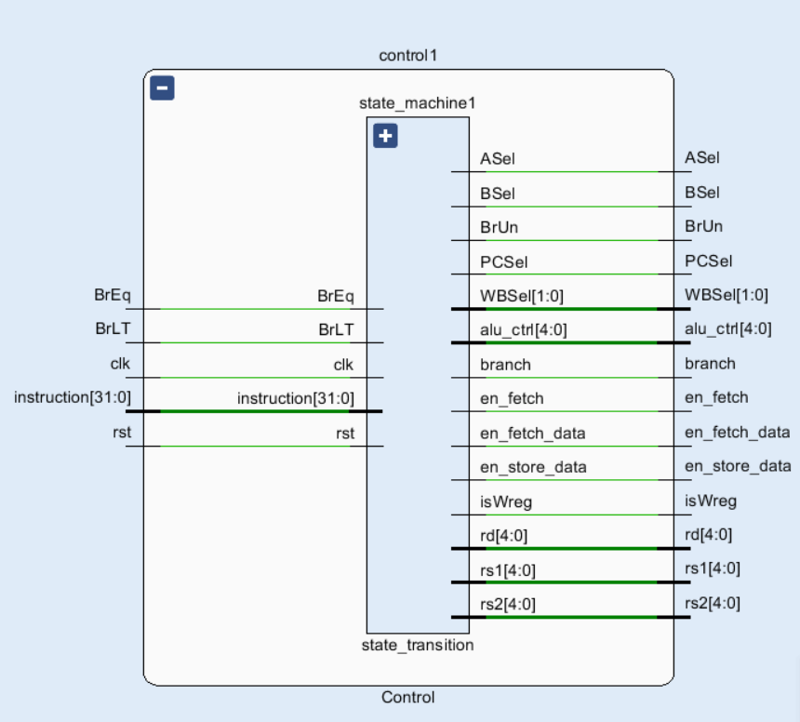
Fig 10 Architecture of Control (State Machine)

3.2.1.4 State Diagram
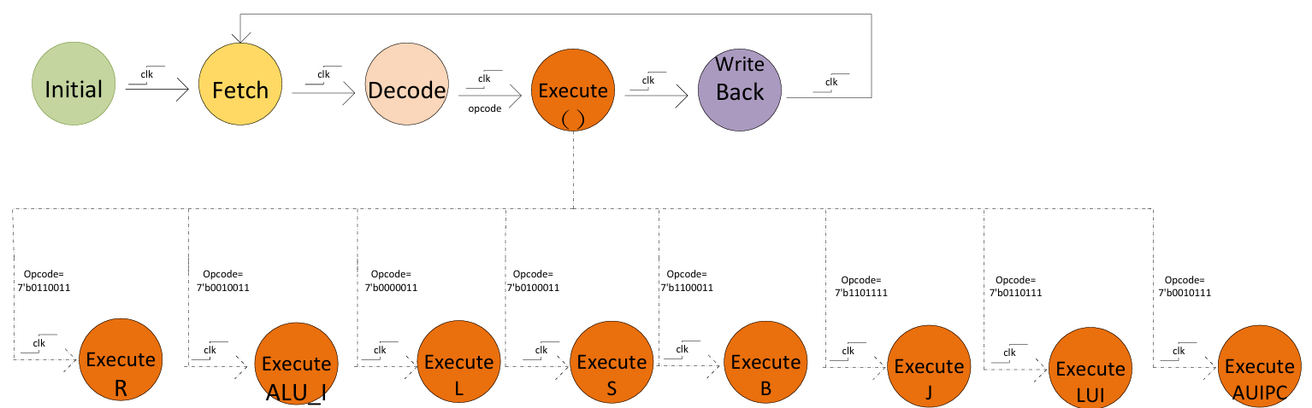
Fig 11 State transition diagram of State Machine

The state diagram shows the working flow of whole CPU. Specifically, in Execute state, different type of it will trigger different signals to be asserted.
R: register type; ALU_I: Immediate type; L: Load type; S: Store type; B: Branch type; J: Jump type; LUI: Load upper Immediate; AUIPC: Add Upper Immediate to PC.

3.2.1.5 Signal Assertion
INITIAL:
Table 18 Signal Assertion of Initial State
FETCH:
Table 19 Signal Assertion of Fetch State
DECODE:
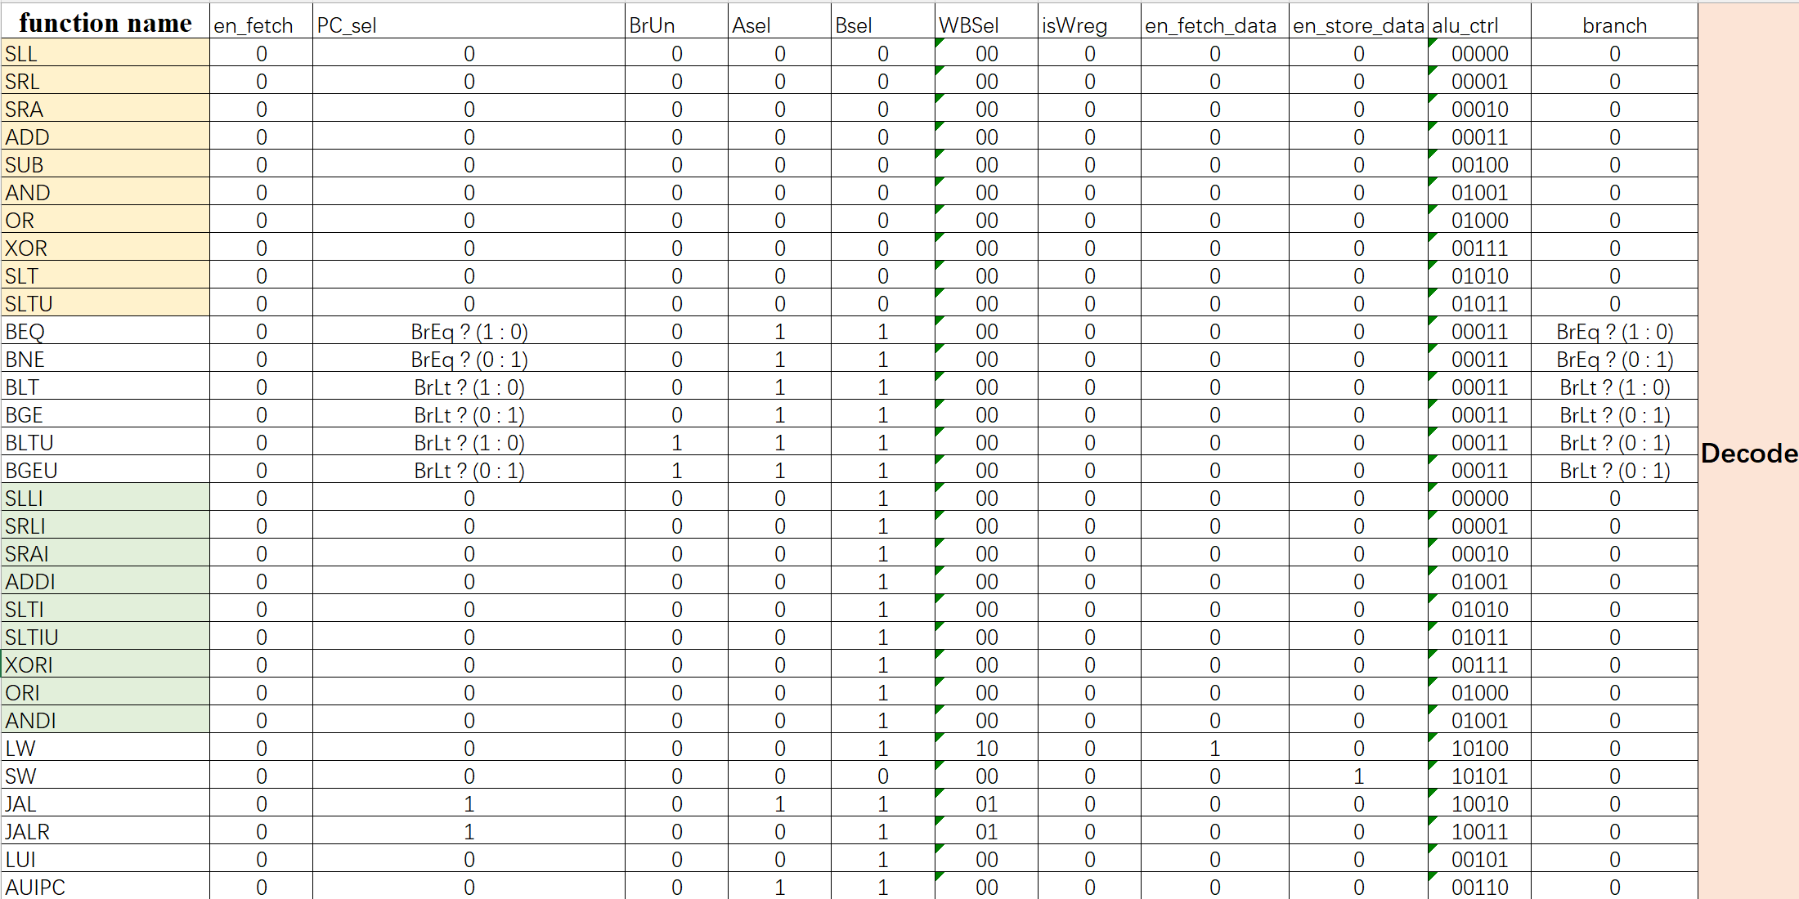
Table 20 Signal Assertion of Decode State

EXCECUTE:
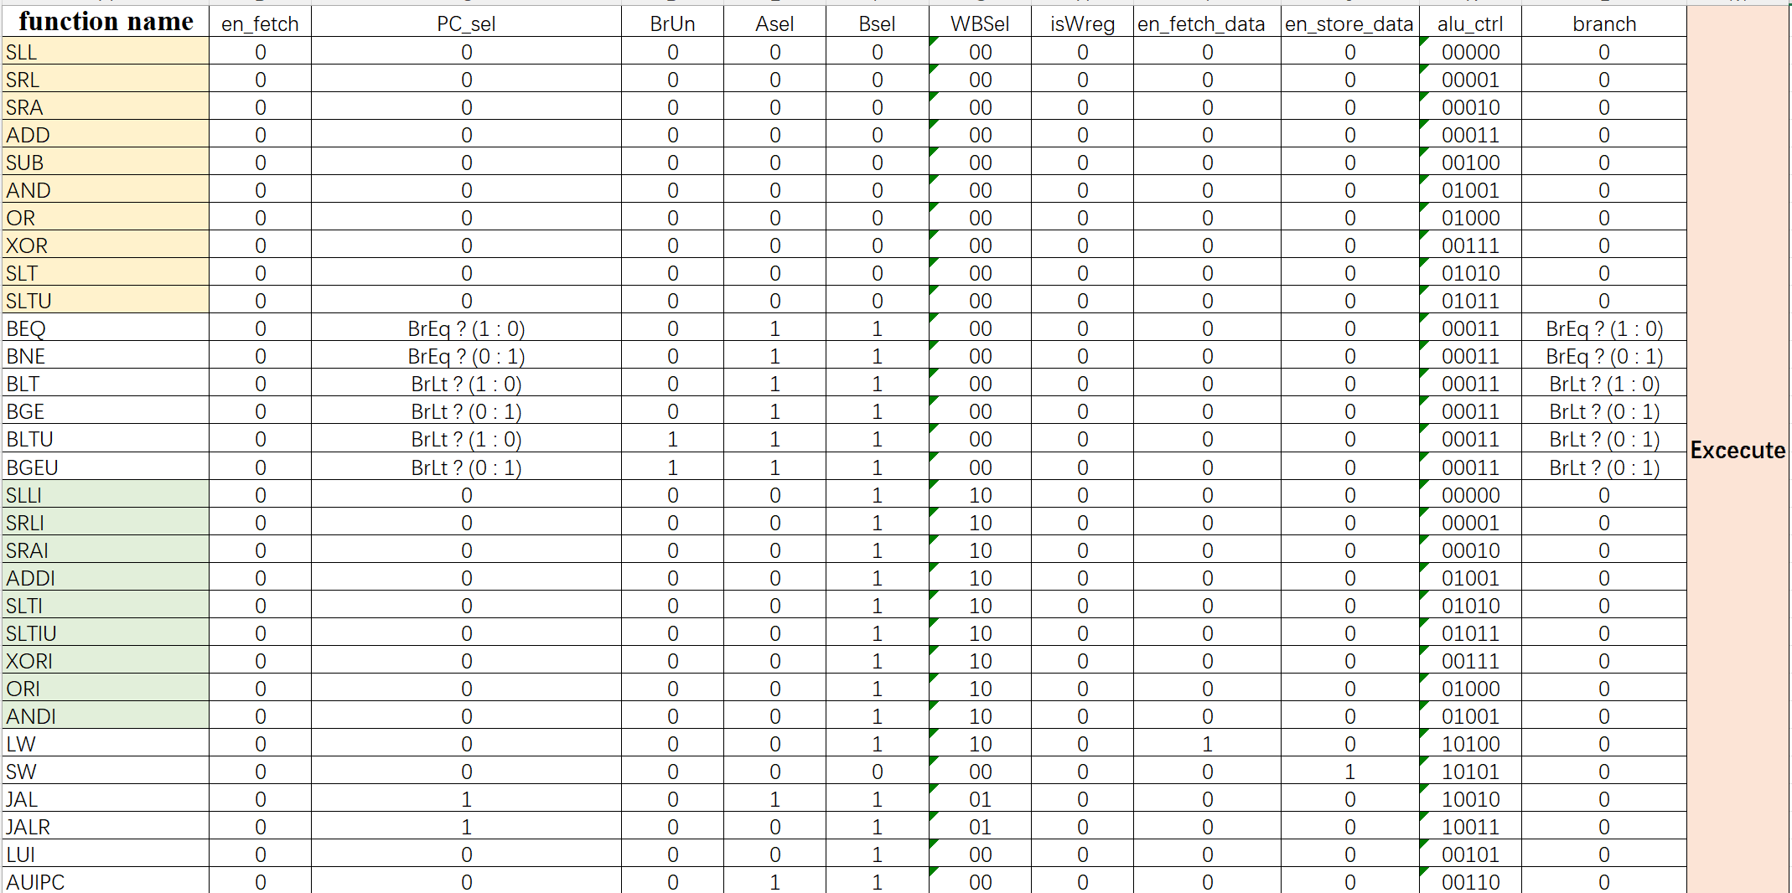
Table 21 Signal Assertion of Execute State
WRITE_BACK:
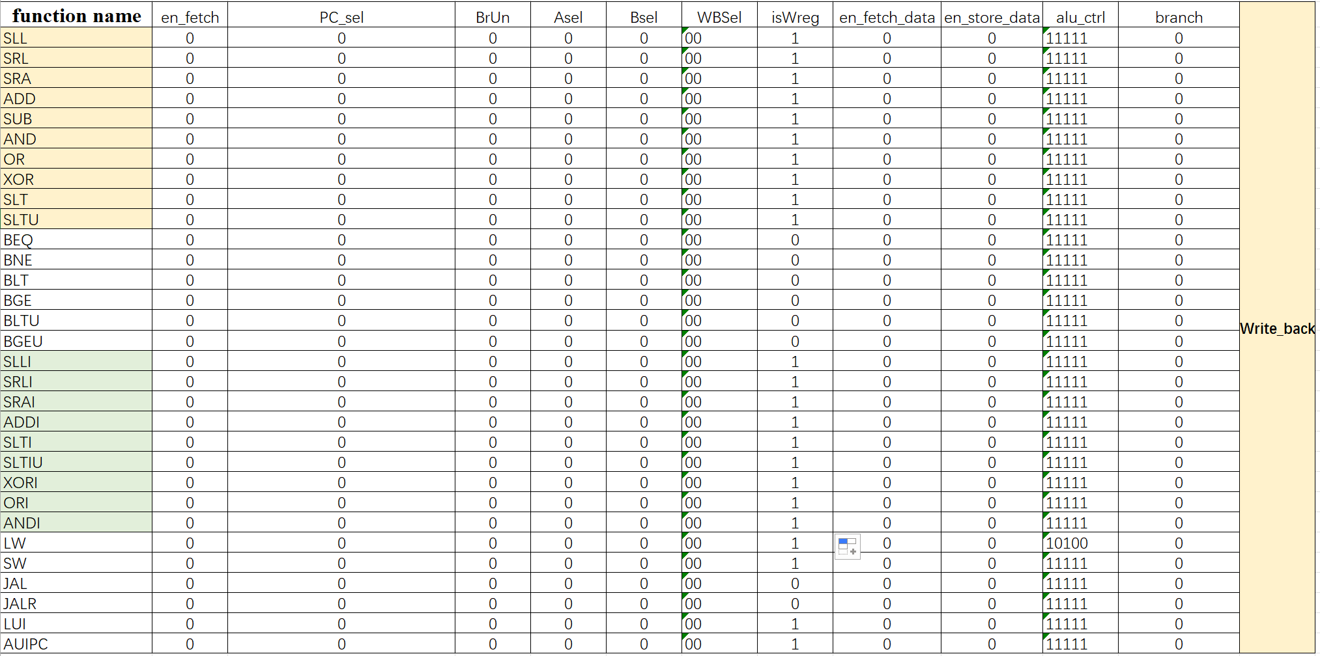
Table 22 Signal Assertion of WB State

3.3 Clock & Reset

3.3.1 Clock (clk)
We used a clock signal with a frequency of 50MHz, which has a clock period of 40ns. It is sent to register file and control (ir and state machine) modules to control behavior of them, ranging from storing data to changing working state.

3.3.2 Reset (rst)
Reset signal is applied in this CPU to set all sequential module the default state. It is detected at negative edge.

3.4 Synthesized Circuit Diagram
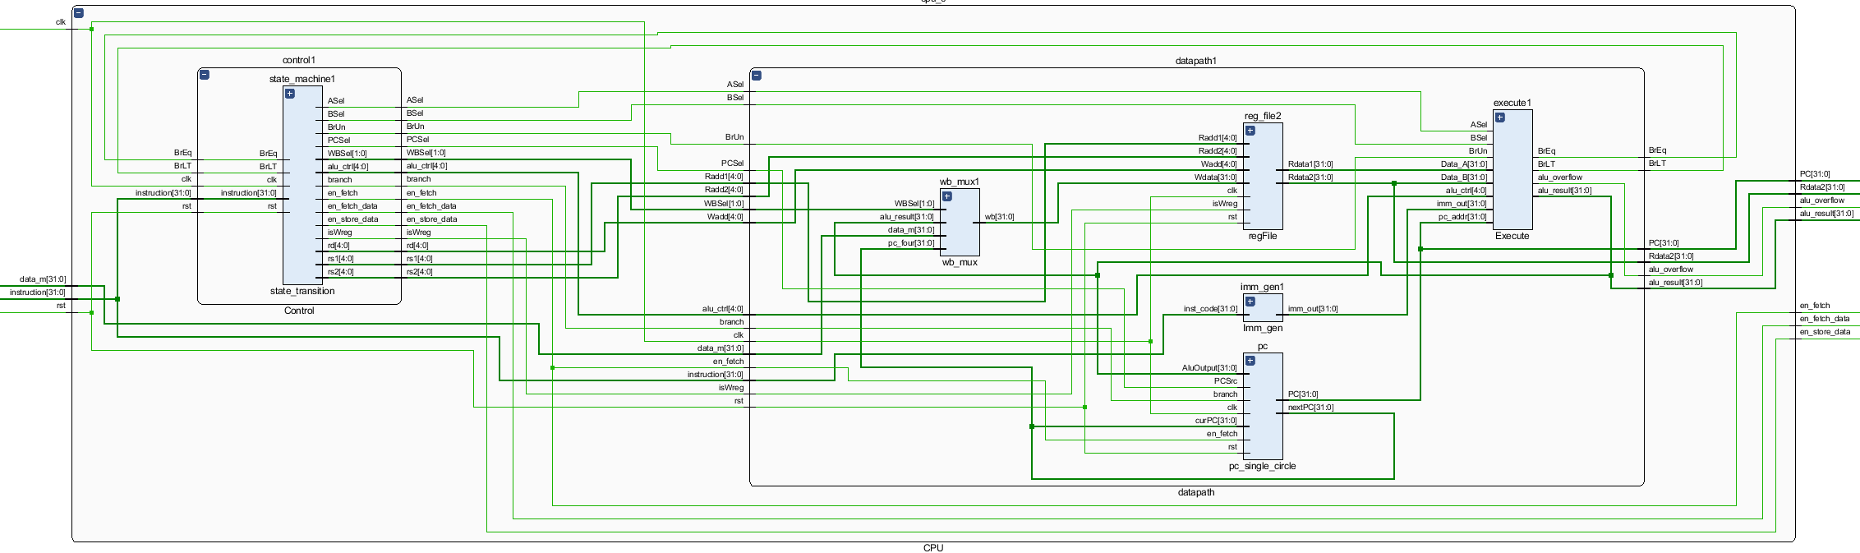
Fig 12 Architecture of the CPU

Verification & Test

4.1 Test Plan & Testbench
First, the main part of CPU-ALU will be verified. Then the CPU will be tested. In order to simulate the scene, a ROM is defined for 20 instructions that will be executed. A RAM is defined for data storage. ROM and RAM will be shown and analyze in latter discussion.

4.2 Testcase & Result
4.2.1 ALU module Test
We simulate ALU separately. The two inputs for ALU are set to 1 and 2, respectively, The alu_ctrl signal is updated every 10ns. Because ALU is a combinational logic, we assume that the output of ALU is instantaneous, and the waveform obtained is as follows:
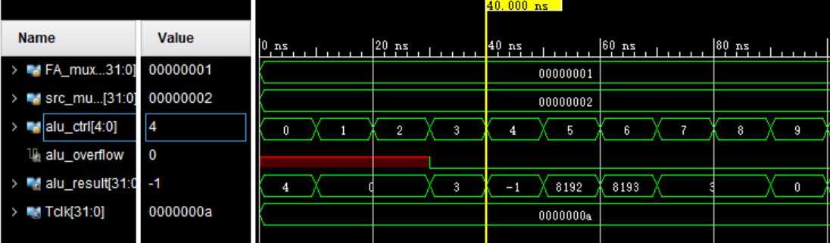
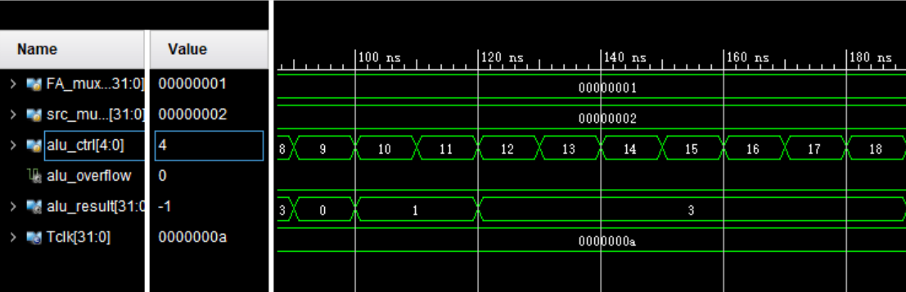
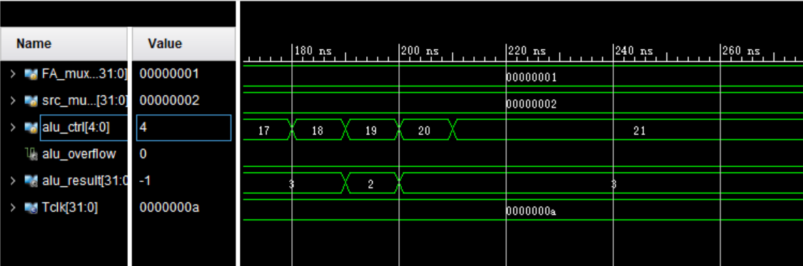
Fig 13 The waveform of ALU under different alu_ctrl signal inputs
We analyze the results one by one:
00000: 1 left shifts by two places to 100, resulting in 4
00001: 1 right shifts by two places, out of range, result is 0
00010: 1 arithmetically shifts two places to the right, out of range, while keeping the high bit 0 unchanged, resulting in 0
00011: Addition, result in 3
00100: Subtraction, equal to 1 adds the complement of 2, resulting in a 16 bit 1, converted to decimal (signed bit) as -1
00101: Keep the lower 20 bits of 2 and move them 12 bits to the left, and fill in the lower 12 bits with 0. The result is
00110: Keep the lower 20 bits of 2 and shift them 12 bits to the left, fill in the lower 12 bits with 0, and add the result to pc, resulting in 8193
00111: XOR, result is 3
01000: Or, result is 3
01001: And, the result is 0
01010: Comparison operation, less than, result is set to 1
01011: Unsigned comparison, less than, result is set to 1
01100-10001: Branch operation, ALU only operates address calculation, that is, addition operation, and the result is all 3
10010: JAL, address calculation, result is 3
10011: JALR, address calculation, and set the lowest result to 0, resulting in 2
10100, 10101: Load and Store, address calculation and sign bit expansion, result in 3
4.2.2 CPU test
(1)Theory: RAM: a RAM was used to store some data in advance.
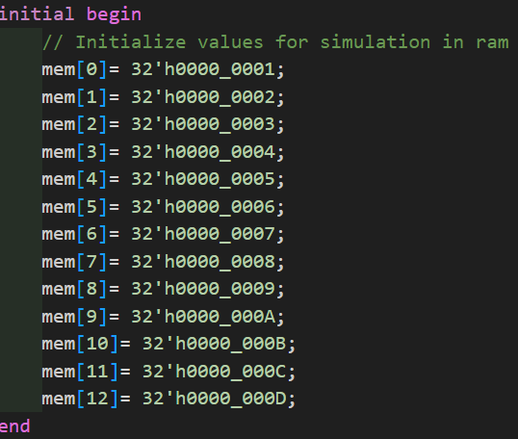
Fig 14 RAM and its values
ROM: ROM pre-defined some instructions to be carried out
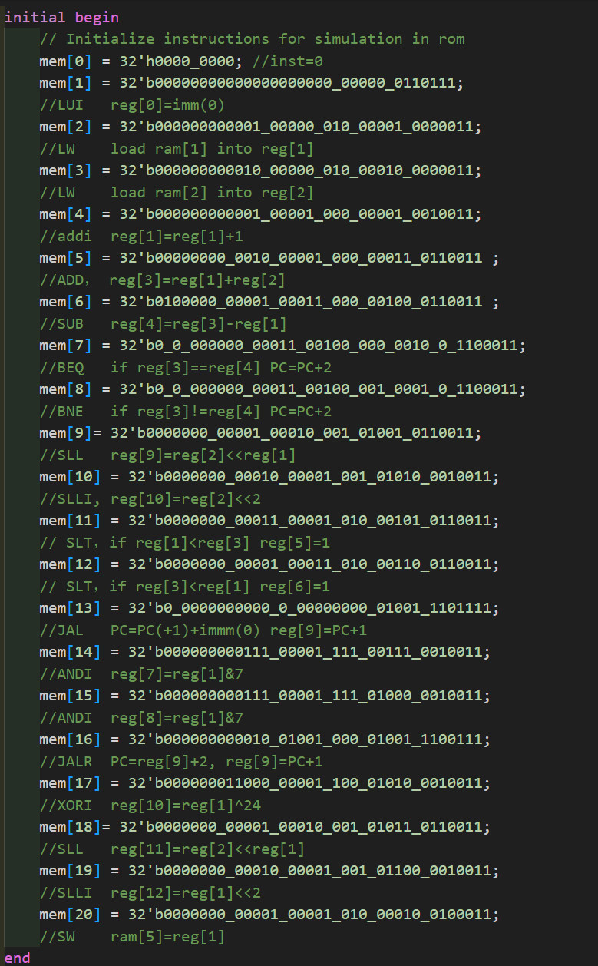
Fig 15 ROM and its Instructions
We analyze the result one by one:
Instru1: LUI (Load Upper Immediate): Loads the immediate value 0 into the upper 20 bits of register reg[0]. This effectively sets reg[0] to 0.
Instru2: LW (Load Word): Loads the word from memory address 1 into register reg[1]. In RAM, ram[1] = 2, this sets reg[1] to 2.
Instru3: LW (Load Word): Loads the word from memory address 2 into register reg[2]. In RAM, ram[2] = 3, this sets reg[2] to 3.
Instru4: ADDI (Add Immediate): Adds the immediate value 1 to the value in reg[1] and stores the result back in reg[1]. This changes reg[1] to 3.
Instru5: ADD: Adds the values in reg[1] and reg[2] and stores the result in reg[3]. This sets reg[3] to 6.
Instru6: Subtracts the value in reg[1] from the value in reg[3] and stores the result in reg[4]. This sets reg[4] to 3.
Instru7: BEQ (Branch if Equal): If the values in reg[3] and reg[4] are equal, the PC is incremented by 2. Since reg[3] is not equal to reg[4], the PC will not be set to PC + 2.
Instru8: BNE (Branch if Not Equal): If the values in reg[3] and reg[4] are not equal, the PC is incremented by 2. This condition is false because reg[3] equals reg[4], so the PC will change here. Theoretically, instru9 and instru10 will not be implemented.
Instru9: SLL (Shift Left Logical): Shifts the value in reg[2] left by the number of positions specified in reg[1] and stores the result in reg[9]. This sets reg[9] to 0x18(24). Due to instru8 this instruction is not executed.
Instru10: SLLI (Shift Left Logical Immediate): Shifts the value in reg[2] left by 2 positions and stores the result in reg[10]. This sets reg[10] to 0xc(12). Due to instru8 this instruction is not executed.
Instru11: SLT (Set Less Than): If reg[1] is less than reg[3], reg[5] is set to 1. Since 3 < 6, this sets reg[5] to 1.
Instru12: SLT (Set Less Than): If reg[3] is less than reg[1], reg[6] is set to 1. Since 6 is not less than 3, this sets reg[6] to 0.
Instru13: JAL (Jump and Link): Sets PC to PC + 1 plus an immediate value 0, and stores the address of the next instruction (i.e., PC + 1) in reg[9].
Instru14: ANDI (AND Immediate): Performs a bitwise AND of the value in reg[1] with the immediate value 7 and stores the result in reg[7]. This sets reg[7] to 3 & 7 which is 3.
Instru15: ANDI (AND Immediate): Performs a bitwise AND of the value in reg[1] with the immediate value 7 and stores the result in reg[8]. This sets reg[8] to 3 & 7 which is 3.
Instru16: JALR (Jump and Link Register): Sets PC to the value in reg[9] plus 2, and stores the address of the next instruction in reg[9].
Instru17: XORI (XOR Immediate): Performs a bitwise XOR of the value in reg[1] with the immediate value 24 and stores the result in reg[10]. This sets reg[10] to 3 ^ 24 which is 0x1b(27).
Instru18: SLL (Shift Left Logical): Shifts the value in reg[2] left by the number of positions specified in reg[1] and stores the result in reg[11]. This sets reg[11] to 0x18(24).
Instru19: SLLI (Shift Left Logical Immediate): Shifts the value in reg[1] left by 2 positions and stores the result in reg[12]. This sets reg[12] to 0xc(12).
Inrtu20: SW (Store Word): Stores the value in reg[1] into memory at the address specified by the offset 2 plus reg[1]. This sets ram[5] to 3.
(2)Practical results:
The corresponding waveform is shown in fig here:
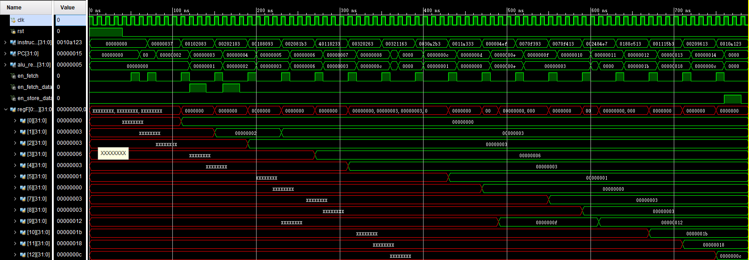
Fig 16 Waveform of simulation results(showing values in registers, PC values and instructions)
By observing values in registers(regFile) and comparing results with theoretical computation, the first 6 instructions were implemented successfully. After instruction 7 and instruction 8 were inplemented, reg[9] and reg[10] did not change immediately. Instead, reg[5] and reg[6] was set to theretical value, indicating that branch (instruction8) was implemented. When PC value reaches 0xd (instruction13 JAL), after decode stage, PC value is 0xe. Then new PC value is set to be PC+0(immediate),which means it will continue to execute instruction 14. Meanwhile, reg[9]was set to be next PC value= 0xe+1=0xf. When program runs to instruction16(JALR) current PC value is 0x11, so reg[9] was set to 0x11+1=0x12(next PC value). At the same time, new PC value will be set to be original value in reg[9](0xf)+imm(2)=0x12 as well, which will read instruction 17. The rest waveform matches theoretical results as well. For instruction20, alu calculated the address for storage,which is 5. It can be seen that ram[5] was always the preset value 6 until this store instruction was initiated and changed to 3.
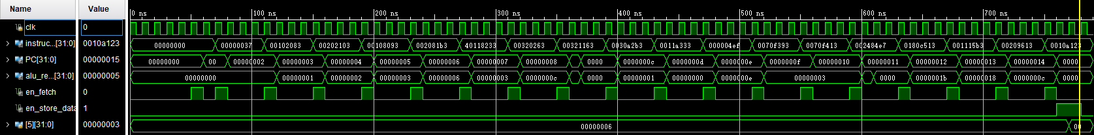
Fig 17 Waveform of simulation results (showing the store result: ram[5] changes from 6 to 3)
(3)Specific Example Analysis
①Instruction3: ADD R1, R1,#1 (reg[1]=reg[1]+1=2+1=3)
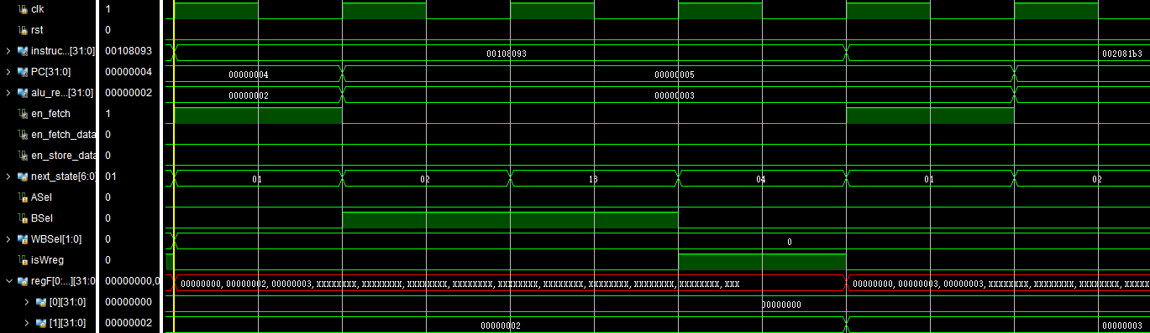
Fig 18 Waveform of Instruction3 (showing all related control signals and results)
Next state is applied as flags to change control signals. 01 is fetch state, so en_fetch was asserted to fetch instruction3 from rom. When next clock rising edge arrives, next state is changed to decode, so ASel is 0 (selecting register value for alu operand 1)while BSel is 1(selecting immediate number for alu operand 2). ALU immediately computed the result:3. Next state is execute(13), WBSel is 0 (selecting alu_result to write back to register[1]). When write back state(04) arrives, isWreg is asserted, wb value is successfully written in register[1], as shown in fig where regF[1] changes from 2 to 3.
②Instruction7&8: 7,BEQ R3, R4; 8,BNE R3,R4
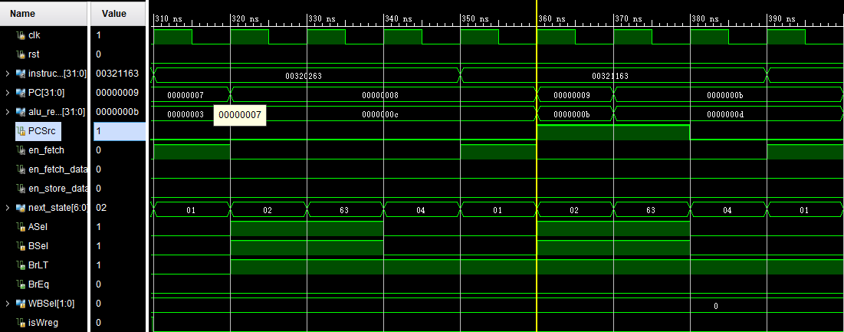
Fig 19 Waveform of Instruction7&8 (showing all related control signals and results)
At decode state ASel is asserted(selecting PC value for alu operand1) and BSel is asserted(selecting immediate number for alu operand2). These 2 instructions both compare reg[3] and reg[4](reg[3]<reg[4]), so BrLT(Branch if Less Than) is asserted and BrEq(Branch if Equal) is 0. At decode stage of instruction8, PCSrc is assigned as 1, which selects alu_result as new PC value,when a new clock rising edge arrives, PC value jumps from 0x9 to 0xb. isWreg is 0 since no value is expected to be written back to any register
③Instruction13:JAL, Jump to PC+0, reg[9]=PC+1
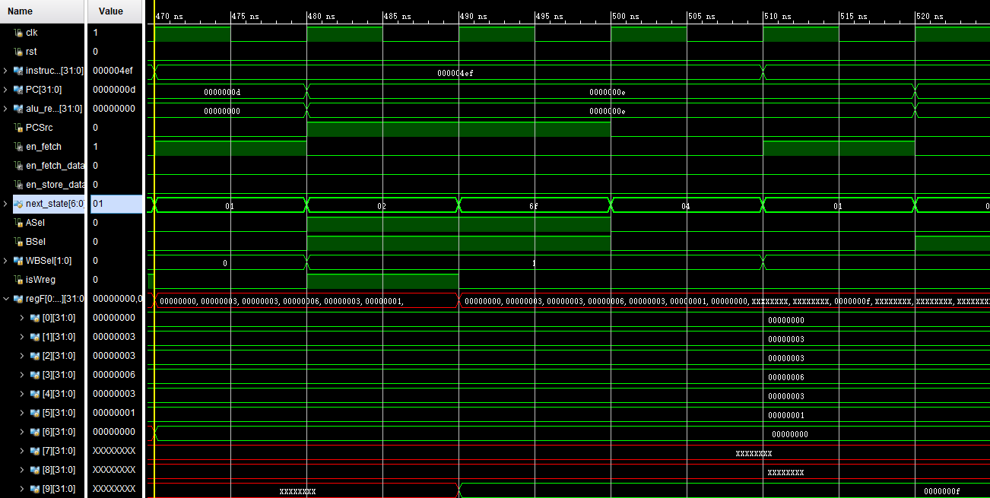
Fig 20 Waveform of Instruction13 (showing all related control signals and results)
At decode state(02), ASel and BSel was asserted to calculate new PC(PC+0=0xe). Next PC(PC+1=0xf) is then write back to reg[9](with WBSel assigned 1). New PC will be chosen with PCSrc asserted.
Conclusion: we can tell that the cpu successfully operated will all signals controlled correctly and data computed precisely. The data flowed and process advanced as anticipated.

4.3 Implementation
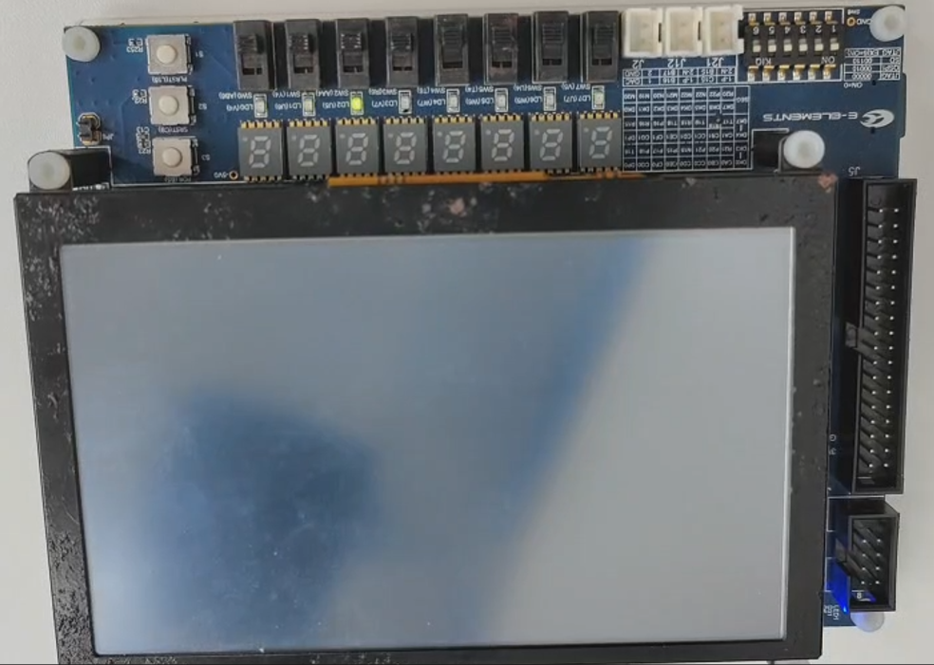
Fig 21 Implementation of Ledwater
Fig.29 shows the implementation of the instructions. However, in the real situation, if the led move once when a shift instruction is finished, the eyes cannot recognize the change the leds and the demonstration is that there is no led light up on the board. This reason for this situation is that the clock frequency on the board is 100MHz so the period is 1×10-8 s. This period is so small that people eyes cannot recognize. Therefore, a small adjustment is employed, which means that the led will not change until the shift instructions are accumulated to 1000000. This changes the changing period from 1×10-8 s to 1×10-2 s that can be distinguished by eyes. The instructions in the ROM is executed repeatedly so that the ledwater is achieved. When the last button is pushed, the ledwater will stop operating whether the ledwater_en is one or zero.

Conclusion & Future work

5.1 Conclusion
We successfully designed this 32 bit multi-cycle CPU which is based on RISC-V ISA. It supports 31 instructions in all. By performing verification and tests for every instruction, and a whole systematic testcase, it is proved that this design successfully works. During the implementation stage, this design also worked on FPGA board to realize a ledwater program, which could be applied to industrial control indication.

5.2 Future work
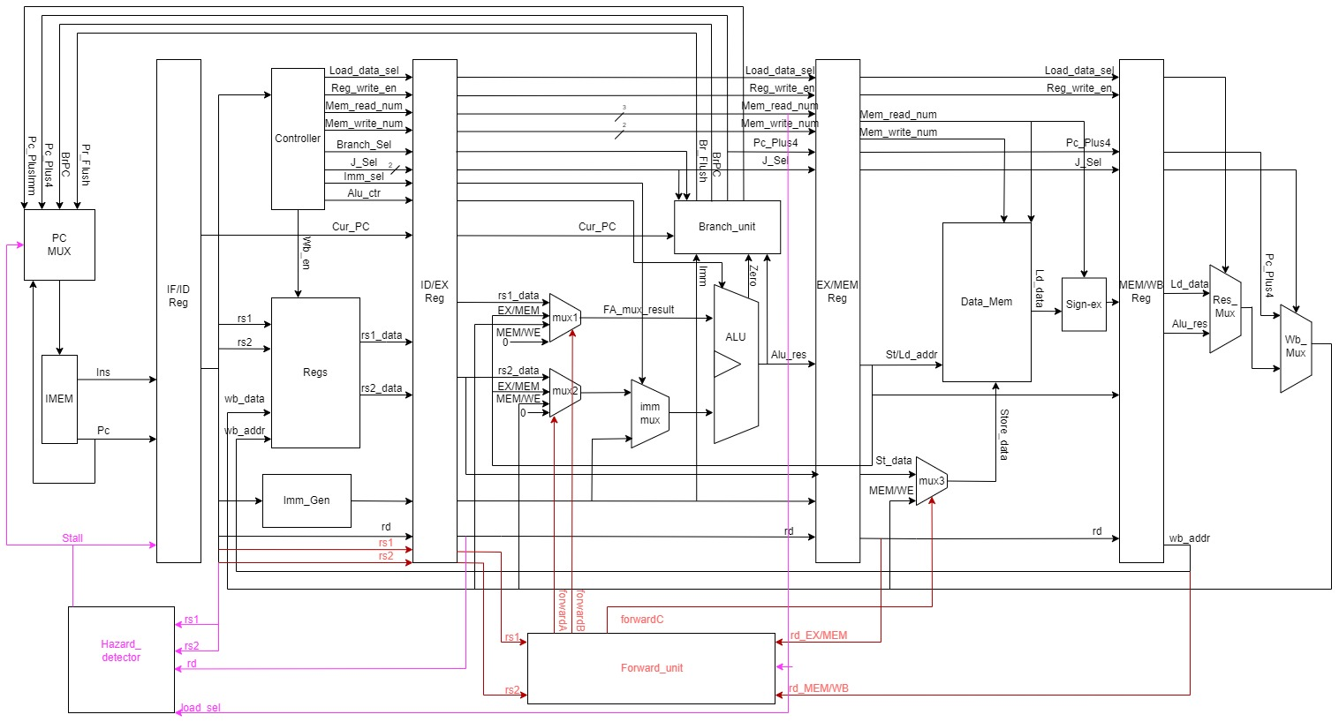
Fig 22 Future upgradation of CPU-5 level pipeline with Hazard detector and Forward Unit

In future design, we will optimize our CPU that requires multiple cycles to execute one instruction into a five-stage pipeline CPU. The modules that need to be added include: four pipeline registers, one forward unit, and one hazard detector. And the Execution module needs to be updated, a Memory-access module for memory operations is added.

Under this CPU design, we can implement more instructions, including read and write operations of different bytes, while significantly improving the CPU's throughput. Suppose our original multi-cycle CPU takes to fully execute one instruction, with a clock cycle of . For this CPU, the throughput is 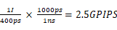.

For a five-stage pipeline, assuming the clock cycle remains unchanged, due to the addition of pipeline registers, the time to fully execute one instruction is (here we assume the delay of each pipeline register is , and we ignore the hazard issues of different instructions). Therefore, its throughput is
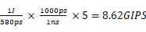.
Therefore, optimizing the CPU structure results in a slight increase in latency but a significant improvement in throughput. However, in actual design, due to the variations in execution time of different modules and the complexity of instructions, this number may fluctuate slightly, which requires further verification. Next, we will briefly introduce the functions of the new modules.

Firstly, we need to know what problems the use of a pipeline will bring, assuming we need to execute the following two instructions:
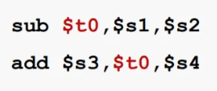
Fig 23 Pipeline Instruction Example
When executing the first instruction, the Execution module will add the values at addresses and . At the same time, the Instruction Decode module will read the values from the register file at addresses and . However, since the first instruction has not yet been written back, the value at address has not been updated. If this value is used directly, it would result in an error. Therefore, we add a Forward Unit to detect such data hazards and directly forward the required values before the Write Back stage, as shown in the diagram below:
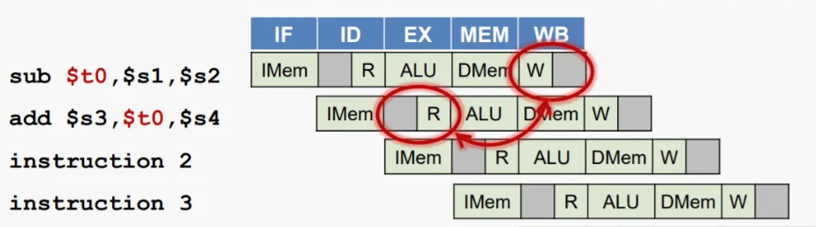
Fig 24 Time/Space Diagram that showcases Hazard Issue

After simple reasoning, we can preliminarily discover the following four types of data risks:
- The Execution module directly requires the data in the Write back module.
- The Execution module directly requires the data in the Memory access module.
- The Execution module directly requires the data the load instruction provides
- The Memory access module directly requires the data in the Write back module, as a store instruction.

For hazards types 1, 2, and 4, we can directly implement real-time forward data through Forward unit. But for the third type of hazard, as the required data may not have been read or retrieved within the current cycle, the entire pipeline needs to pause for one cycle to wait for the Load instruction to complete before passing the data to the Execution section in the write back phase. And to generate this pause, which is the bubble, it requires the Hazard detector. The two selectors added in the Execution module, as well as the one added in the Memory access module, are all used for data selection: selecting the data passed in the previous stage or 0 to pause the pipeline.

In addition to data hazards, there may also be two other types of hazards within the pipeline CPU: structural hazard and control hazard. For the hazard of simultaneously reading and writing memory, we can use the Harvard structure to effectively avoid it; For the hazard of reading and writing register simultaneously, we can set the first half of the clock cycle for writing and the second half cycle for reading, and set independent read and write ports. Controlling hazards is mainly generated by Branch and jump instructions, which can be avoided by using pauses and branch predictions. This is also a direction that needs to be addressed in the future, which will not be further elaborated here.

References
- G. Sun, S. Lin, F. Yu, B. Yan, and J. Zhang, “Multi-rate Based Channel Assignment Algorithm for Multi-radio Multi-channel Wireless Mesh Networks,” in 2015 11th International Conference on Mobile Ad-hoc and Sensor Networks (MSN), 2015, pp. 202–207.
- Lisa Yan and Justin Yokota. “CS 61c spring 2024,” Home | CS 61C Spring 2024. (Jan. 2024), [Online]. Available: https://cs61c.org/sp24/ [Accessed: 05/03/2024].
- [1] J. F. Wakerley, "Digital Design: Principles and Practices", 4th ed., New York: Prentice Hall, 2006.

